# IT 315 Final Project Part I Solution Submission Template

This template is a guide for you to organize your information. To complete it, **replace the bracketed text with the relevant information.** Some areas may be too large or too small for the information you’re inserting. Adjust the size of the areas as necessary.

**Name:** [Joseph Silva Jr.]

**Date:** [01/30/21]

1. **Creation:** Generate your student information system (SIS) use case diagram. Refer to textbook pages 121–129.

[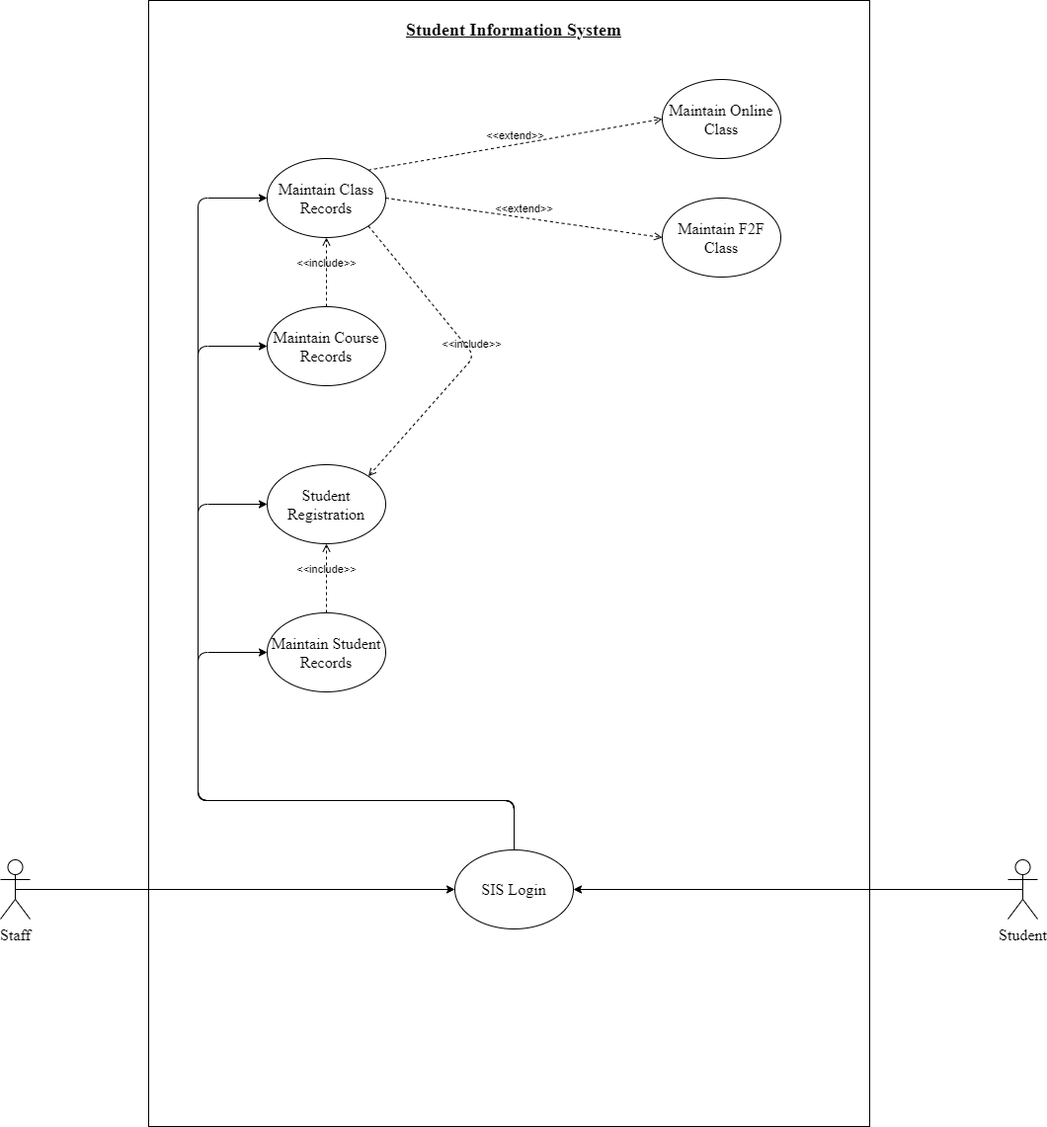]

1. Using the **use case description template** (refer to textbook pages 141–148), provide a description for **each** use case in your use case diagram:

**Use Case 1 description template:**

[

|  |  |  |
| --- | --- | --- |
| Use Case Name:  [Maintain Student Records] | ID:  [1] | Importance Level:  [3] |
| Primary Actor:  [Staff] | Use Case Type:  [Detail and Essential.] | |
| Stakeholders and Interests:  [Staff and Student.] | | |
| Brief Description:  [Area of the system that stores and displays records of each student’s general information] | | |
| Trigger:  [Staff and Student have access to student records. Only Staff has ability to edit records.]  Type:  [External Trigger.] | | |
| Relationships   * Association:   [Staff and Student.]   * Include:   [Student’s General Information such as Student’s name, DOB, GPA, Student ID & Department.]   * Extend:   [Staff Ability to edit student records such as add, delete, and modify.]     * Generalization:   [Manage Student Records.] | | |
| Normal Flow of Events:   * Staff or Student triggers Student Records. * Staff or Student is able view general information of Students | | |
| SubFlows:   * Staff able to edit a student’s record by adding, deleting, or modifying information * After information changed, a confirmation requirement will be asked to staff. * After confirmation is completed, new information will be added to the records. | | |
| Alternate/Exceptional Flows:  [Insert information.] | | |

]

**Use Case 2 description template:**

[

|  |  |  |
| --- | --- | --- |
| Use Case Name:  [Maintain Course Records] | ID:  [2] | Importance Level:  [3] |
| Primary Actor:  [Staff] | Use Case Type:  [Detail and Essential.] | |
| Stakeholders and Interests:  [Staff and Student.] | | |
| Brief Description:  [Area of the system that stores and displays records of each course’s general information] | | |
| Trigger:  [Staff and Student have access to course records. Staff only has ability to edit records.]  Type:  [External Trigger.] | | |
| Relationships   * Association:   [Staff and Student.]   * Include:   [Courses’ General Information such as Course ID, name, credit hours, description & prerequisite courses.]   * Extend:   [Staff Ability to edit course records such as add, delete, and modify.]     * Generalization:   [Manage Course Records.] | | |
| Normal Flow of Events:   * Staff or Student triggers Course Records. * Staff or Student is able view general information of Courses. | | |
| SubFlows:   * Staff able to edit a course’s record by adding, deleting, or modifying information * After information changed, a confirmation requirement will be asked to staff. * After confirmation is completed, new information will be added to the records. | | |
| Alternate/Exceptional Flows:  [Insert information.] | | |

]

**Use Case 3 description template:**

[

|  |  |  |
| --- | --- | --- |
| Use Case Name:  [Maintain Class Records] | ID:  [3] | Importance Level:  [3] |
| Primary Actor:  [Staff] | Use Case Type:  [Detail and Essential.] | |
| Stakeholders and Interests:  [Staff and Student.] | | |
| Brief Description:  [Area of the system that stores and displays records of each class’ record’s general information] | | |
| Trigger:  [Staff and Student have access to course records. Staff only has ability to edit records.]  Type:  [External Trigger.] | | |
| Relationships   * Association:   [Staff and Student.]   * Include:   [Class General Information such as Course ID, begin date & end date. Manage Couse Records.]   * Extend:   [Staff Ability to edit course records such as add, delete, and modify. Manage Online Class Records & Manage F2F Class Records.]     * Generalization:   [Manage Class Records.] | | |
| Normal Flow of Events:   * Course needs to be created before class record can be created * Staff or Student triggers Class Records. * Staff or Student is able view general information of Classes. | | |
| SubFlows:   * Staff able to edit a class record by adding, deleting, or modifying information * After information changed, a confirmation requirement will be asked to staff. * After confirmation is completed, new information will be added to the records. | | |
| Alternate/Exceptional Flows:  [Insert information.] | | |

]

**Use Case 4 description template:**

[

|  |  |  |
| --- | --- | --- |
| Use Case Name:  [Maintain Student Registration Records] | ID:  [4] | Importance Level:  [3] |
| Primary Actor:  [Staff] | Use Case Type:  [Detail and Essential.] | |
| Stakeholders and Interests:  [Staff and Student.] | | |
| Brief Description:  [Area of the system that stores, displays and modify records of each student registration record.] | | |
| Trigger:  [Staff and Student have access to course records. Staff only has ability to edit records.]  Type:  [External Trigger.] | | |
| Relationships   * Association:   [Staff and Student.]   * Include:   [Manage Student Records and Manage Class Records.]   * Extend:   [Ability to edit student registration records such as add, delete, and modify.]     * Generalization:   [Manage Student Registration Records.] | | |
| Normal Flow of Events:   * Staff or Student triggers Student Registration Records. * User adds a student ID information to gain access to registration records associated with that student ID. * Staff or Student is given the ability to add, delete, and modify registration records for the attached student ID. * New information stored after selection * Registration process restarts at Guideline (b) * Student can continue to add additional classes to registration query until query = 3. | | |
| SubFlows: | | |
| Alternate/Exceptional Flows:   * A Student or Staff unable to confirm a Student has the required Hardware or Software for an Online Class. * Student ID associated with a GPA lower than a 3.5+. * A class chosen during the registration process is a duplicate of a class already in the Student ID’s query of class registration . | | |

]

**Use Case 5 description template:**

[

|  |  |  |
| --- | --- | --- |
| Use Case Name:  [Online Classes] | ID:  [5] | Importance Level:  [4] |
| Primary Actor:  [Staff] | Use Case Type:  [Detail and Essential.] | |
| Stakeholders and Interests:  [Staff and Student.] | | |
| Brief Description:  [Area of the system that stores and displays information for the online classes] | | |
| Trigger:  [Staff and Student have access to course records.]  Type:  [External Trigger.] | | |
| Relationships   * Association:   [Staff and Student.]   * Include:   [Web Browser and URL]   * Extend:   [Manage Class Records]     * Generalization:   [Manage Online Class Records.] | | |
| Normal Flow of Events: | | |
| SubFlows: | | |
| Alternate/Exceptional Flows: | | |

**Use Case 6 description template:**

[

|  |  |  |
| --- | --- | --- |
| Use Case Name:  [F2F Classes] | ID:  [6] | Importance Level:  [4] |
| Primary Actor:  [Staff] | Use Case Type:  [Detail and Essential.] | |
| Stakeholders and Interests:  [Staff and Student.] | | |
| Brief Description:  [Area of the system that stores and displays information on F2F classes] | | |
| Trigger:  [Staff and Student have access to information.]  Type:  [External Trigger.] | | |
| Relationships   * Association:   [Staff and Student.]   * Include:   [Building and Classroom location]   * Extend:   [Manage Class Records.]     * Generalization:   [Manage F2F Class Records.] | | |
| Normal Flow of Events: | | |
| SubFlows: | | |
| Alternate/Exceptional Flows: | | |

1. **Testing:** Verify and validate your use case diagram and use case descriptions against the SIS requirements definition.

Check your diagram against the SIS requirements and write this review. In doing verification, the objective is to make sure that you are building software according to user specifications. Ask questions like these: Does each use case have the required functionality? Do all the use cases combined perform as a complete coherent system?

[Comparing the SIS guidelines and my diagram, we can see the nonfunctional requirements are taken care of at the beginning of the diagram. The actors are able to access the system using the internet and then they are able to access the use cases within the system.

Next, the system functional requirements are handled after log in. After reviewing the feedback from my initial assignment, I showed the relationships between the actors and the use cases. The main use cases were the following: Student Registration, Student Records, Course Records, Class Records, Online Class Records, and F2F Class Records. Most of the use cases have relationship between each other. For Maintain Course Records and Maintain Class Records, they have an included relationship with each other because the Class Records uses a piece of the Course Records. The Class Records uses the Course ID attribute from the Course Records because a class could not be created without an associated course. The Student Record is also included in the student registration because prior to registering the Student ID is required to gain access for registration and the different types of classes in the Class Records are displayed in the Student Registration to allow Students or Staff to choose these classes for a student’s registration. The Online Class Records and F2F Class Records are both extensions of the Class Records because they use the Class Records use case, but they just have additional detail for each class records.]

1. **Approach Explanation:** Explain your approach to the problem, the decisions you made to arrive at your solution, and how you completed it.

Explain why you chose these particular use cases and why you chose the relationships between them. Explain your approach to creating your functional model and the design decisions you made to create it.

[I approached this assignment by following the Student Information System Guidelines and the created a workflow first in order to have a map for me to follow while writing my report. The reason I created my diagram model to show the route the actors of the system can take and how the use cases were connected. I was able to simplify my new diagram from my previous diagram by following the feedback from my initial assignment and I only placed the main use cases within the diagram.]

1. **Self-Reflection:** Reflect on this experience and the lessons you learned from it.

These are your reflections on what you learned. Address what you found challenging and what you found easy. Discuss your experience creating your functional model and the lessons you learned from it. Specifically, draw connections between your experience and the object-oriented techniques and methods discussed in this course.

[When I first created my diagram, I had a difficult time showing the relationships between the actors and the use cases because I had two actors, who had different restrictions of access for each use case. I color schemed the relationship to show which actor was allowed the certain privileges within the use cases. After I received the feedback from the initial assignment, I placed only the main use cases within my diagram and the diagram was displayed simpler than its predecessor. I felt my new diagram was easier to explain because I was able to get rid of the non-main use cases within the diagram.]